Now that two successful cataract surgeries have been completed, it’s time to resume our monthly Metro with Dave trips.
Next Trip – February 18th – Museum of Flight

Metro Day with Dave Newsletter
Upcoming Trip:
March 17th --
Riding the First Hill Streetcar
  - Volume 2 | Issue 2
February, 2016
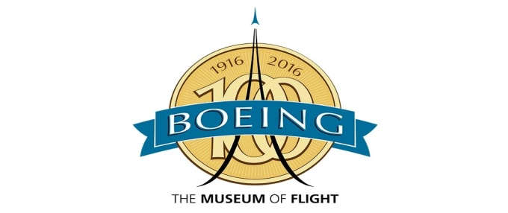
The Museum of Flight always offers outstanding exhibits for aviation enthusiasts but 2016 is going to be a special year. Boeing is celebrating their centennial in 2016 and the Museum of Flight will take part in the celebrations with special artifacts, exhibits, and lectures honoring the Boeing company and Boeing aircraft evolution.
Museum admission: General admission: $20 (adults), $17 (seniors 65+), AAA members: $18 (adults), $15 (seniors 65+), MOF members: free
We also have $2 off regular admission coupons for anyone that wants one.
The Museum also offers Group rates for groups of 10 or more. Groups receive a lower admission rate than the regular rates but they also receive a complimentary custom Museum tour by a docent. Since we would have to pre-register with the Museum Group department if we are able to get a minimum of 10 people, please RSVP to davids_waggoner@msn.com by Tuesday, February 9th so that we can get an idea how many people will want to go on this trip and if we would qualify as a group. If we are able to register as a group, we will let you know more information closer to the date.
We will meet at the City Hall bus stop no later than 10:15am on February 18th and take the ST #554 at 10:26am to downtown Seattle. We will get off the ST #554 at 4th Ave and S. Washington St. and walk about 2 blocks to 2nd Ave and S. Main St. where we will catch the Metro #124 at approximately 11:25am. We should arrive at the MOF at 11:45am.
Lunch will be on own at the Wings Café.

To return to Issaquah, we will catch the Metro #124/24 at the MOF at 2:33pm, get off at 4th Ave and Jackson St and walk about a block to the 5th Ave and Jackson St. stop to catch the ST #554 at 3:10pm. We should arrive at the bus stop across the street from City Hall at 3:44pm.
One way bus fare:
 | Adult |  | Youth |  | Senior
Route | ORCA | Cash | ORCA | Cash | ORCA | Cash
554 | 2.50 | 2.50 | 1.25 | 1.25 | 0.75 | 0.75
124/24 | 0.00 | 2.50 | 0.25 | 1.50 | 0.25 | 1.00
Total | 2.50 | 5.00 | 1.50 | 2.75 | 1.00 | 1.75

Save the Date -- ORCA To Go in Issaquah – February 19th

Do you need to add funds to your ORCA card? Get a monthly pass? Want to get a Senior ORCA card or find out about the ORCA Lift program? The ORCA To Go team will be in the Eagle Room of the Issaquah City Hall on February 19th. Stop by anytime from 10am to 2pm, no appointment necessary.

Contact Dave at davids_waggoner@msn.com or call his cell (425) 221-2503 if you have questions about this trip or suggestions for future Metro with Dave trips.

